**TASK 2**

**Project: Student Database Management System**

**Project Description:**

Design and implement a student database management system using PostgreSQL that allows storing and retrieving student information efficiently.

1. **Database creation**

**Code-** CREATE DATABASE student_database;

USE student_database;

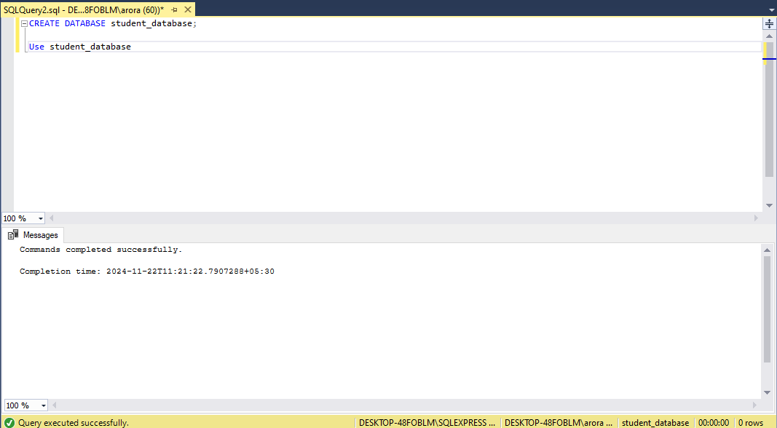

1. **Creation of Tables**

**Code-** CREATE TABLE student_table (

Student_id INT PRIMARY KEY IDENTITY(1,1),

Stu_name VARCHAR(50) NOT NULL,

Department VARCHAR(50) NOT NULL,

email_id VARCHAR(50) NOT NULL,

Phone_no NUMERIC(10) NOT NULL,

Address VARCHAR(50),

Date_of_birth DATE NOT NULL,

Gender VARCHAR(50) CHECK (Gender IN ('Male', 'Female', 'Other')),

Major VARCHAR(50),

GPA NUMERIC(3, 2),

Grade VARCHAR(50) CHECK (Grade IN ('A', 'B', 'C', 'D', 'F')));

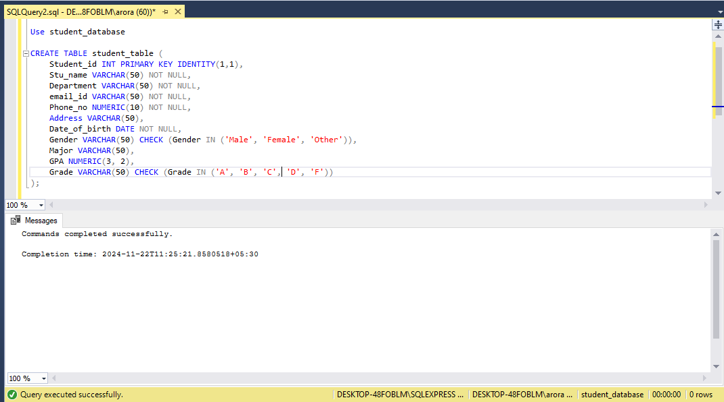

1. **Insertion of Values**

**Code**- INSERT INTO student_table (Stu_name, Department, email_id, Phone_no, Address, Date_of_birth, Gender, Major, GPA, Grade) VALUES

('Aarav Patel', 'Computer Science', 'aarav.patel@example.com', 9876543210, '123 Bangalore, Karnataka', '2000-10-01', 'Male', 'Software Engineering', 3.80, 'A'),

('Priya Sharma', 'Mechanical Engineering', 'priya.sharma@example.com', 9123456789, '456 Delhi, India', '2001-05-15', 'Female', 'Thermodynamics', 3.65, 'B'),

('Rahul Verma', 'Electrical Engineering', 'rahul.verma@example.com', 9009876543, '789 Mumbai, Maharashtra', '1999-07-20', 'Male', 'Circuits and Systems', 3.40, 'C'),

('Ananya Gupta', 'Civil Engineering', 'ananya.gupta@example.com', 8787878787, '101 Noida, Uttar Pradesh', '2002-01-10', 'Female', 'Structural Engineering', 3.90, 'A'),

('Vishal Reddy', 'Information Technology', 'vishal.reddy@example.com', 8223344556, '202 Hyderabad, Telangana', '2000-11-30', 'Male', 'Web Development', 3.50, 'B'),

('Isha Joshi', 'Biotechnology', 'isha.joshi@example.com', 9988776655, '303 Pune, Maharashtra', '2001-03-25', 'Female', 'Genetics', 3.85, 'A'),

('Karan Singh', 'Chemical Engineering', 'karan.singh@example.com', 9856347231, '404 Jaipur, Rajasthan', '2000-08-05', 'Male', 'Process Engineering', 3.20, 'C'),

('Sneha Kumar', 'Electrical Engineering', 'sneha.kumar@example.com', 9776334455, '505 Chennai, Tamil Nadu', '2000-06-14', 'Female', 'Power Systems', 3.75, 'B'),

('Rohit Yadav', 'Mechanical Engineering', 'rohit.yadav@example.com', 9662112233, '606 Ahmedabad, Gujarat', '2001-09-17', 'Male', 'Automotive Engineering', 3.60, 'B'),

('Neha Nair', 'Civil Engineering', 'neha.nair@example.com', 9444556677, '707 Kochi, Kerala', '2000-04-22', 'Female', 'Water Resources Engineering', 3.95, 'A');

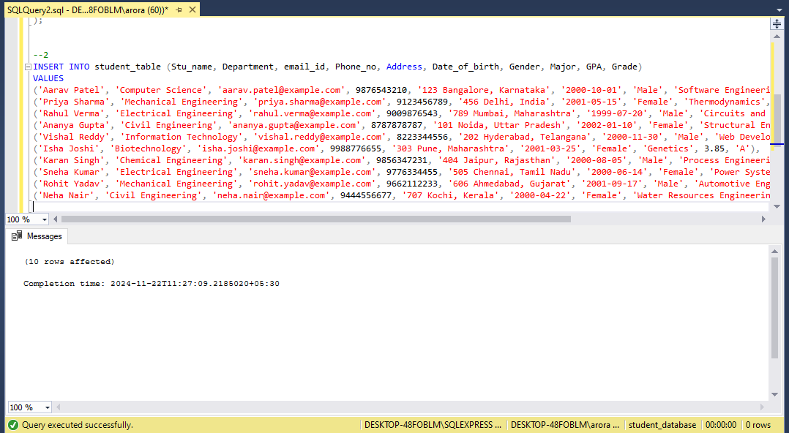

**4. Develop a query to retrieve all students' information from the "student_table" and sort them in descending order by their grade.**

**Code-** SELECT *

FROM student_table

ORDER BY Grade DESC;

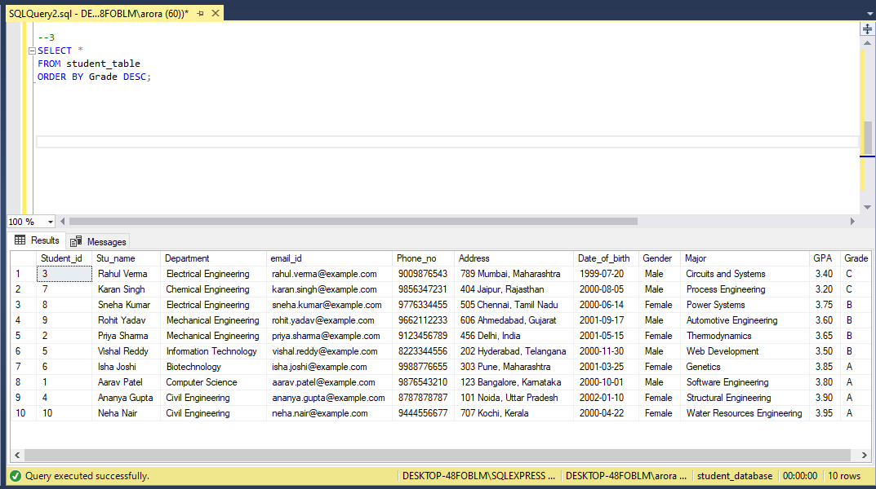

**5. Implement a query to retrieve information about all male students from the "student_table."**

**Code-** SELECT *

FROM student_table

WHERE Gender = 'Male';

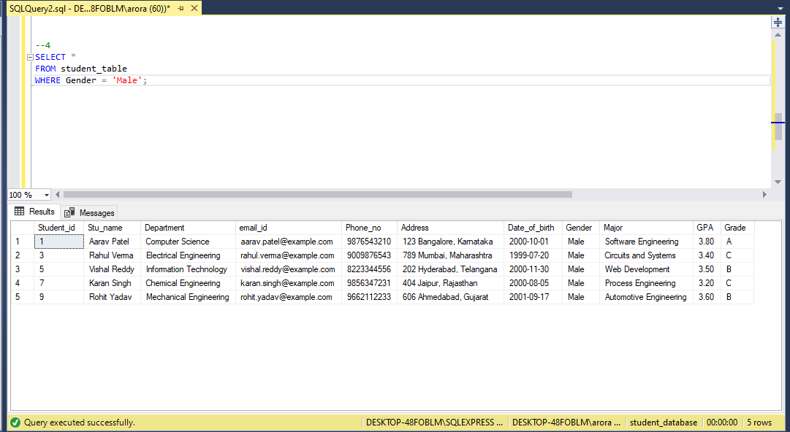

**6. Create a query to fetch the details of students who have a GPA less than 5.0 from the "student_table."**

**Code-** SELECT *

FROM student_table

WHERE GPA < 5.0;

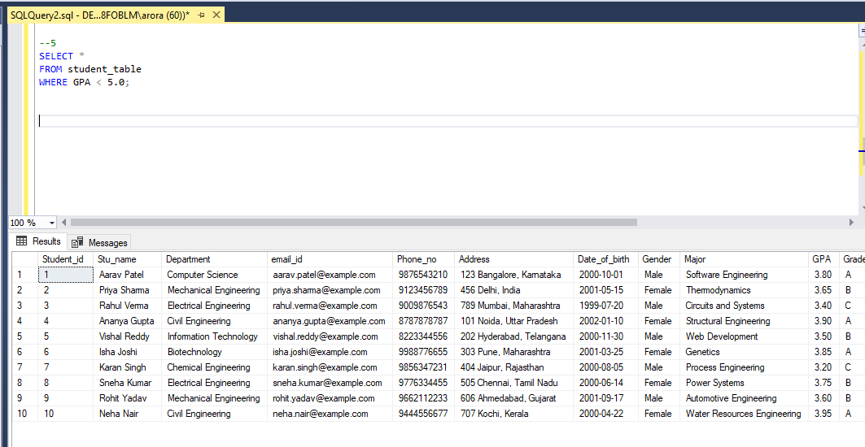

**7. Write an update statement to modify the email and grade of a student with a specific ID in the "student_table."**

**Code-** UPDATE student_table

SET

email_id = 'newemail3@example.com',

Grade = 'A'

WHERE

Student_id = 3;

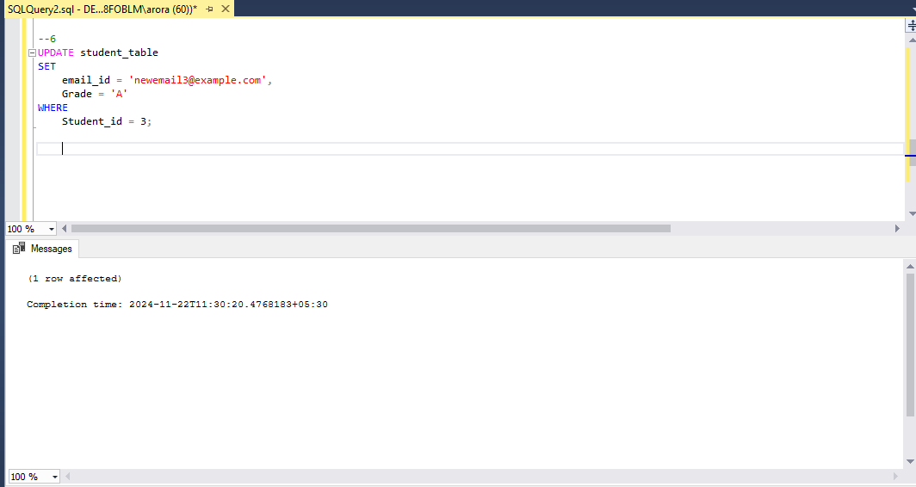

**8. Develop a query to retrieve the names and ages of all students who have a grade of "B" from the "student_table."**

**Code-** SELECT

Stu_name,

DATEDIFF(YEAR, Date_of_birth, GETDATE()) -

CASE

WHEN MONTH(Date_of_birth) > MONTH(GETDATE()) OR

(MONTH(Date_of_birth) = MONTH(GETDATE()) AND DAY(Date_of_birth) > DAY(GETDATE()))

THEN 1

ELSE 0

END AS Age

FROM

student_table

WHERE

Grade = 'B';

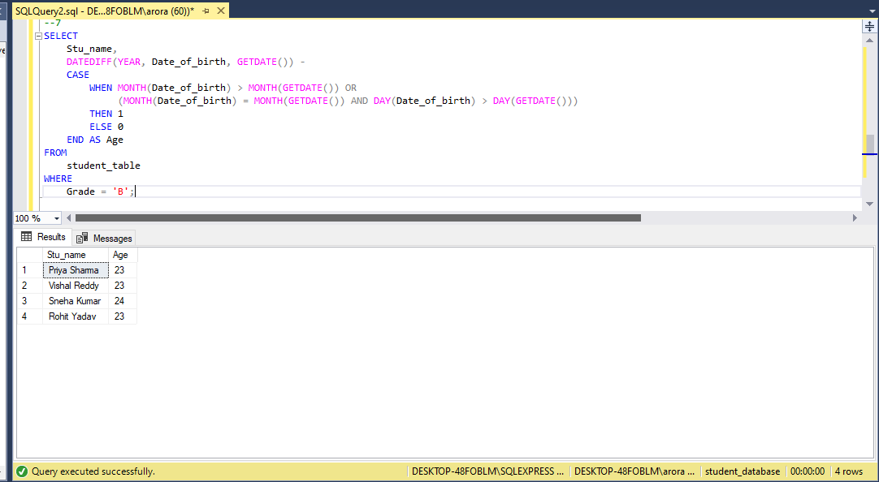

**9. Create a query to group the "student_table" by the "Department" and "Gender" columns and calculate the average GPA for each combination.**

**Code-** SELECT

Department,

Gender,

AVG(GPA) AS Average_GPA

FROM

student_table

GROUP BY

Department, Gender;

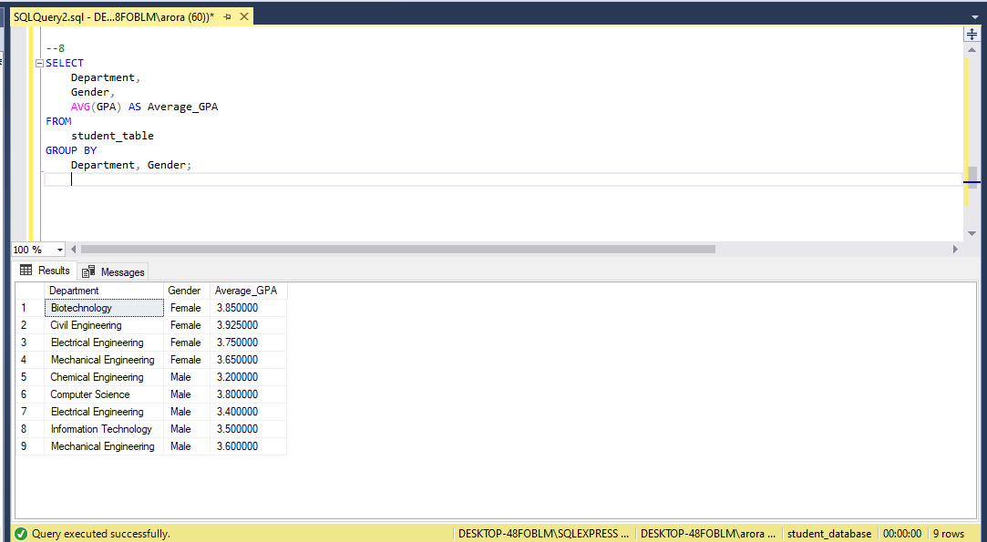

**10. Rename the "student_table" to "student_info" using the appropriate SQL statement.**

**Code-** EXEC sp_rename 'student_table', 'student_info';

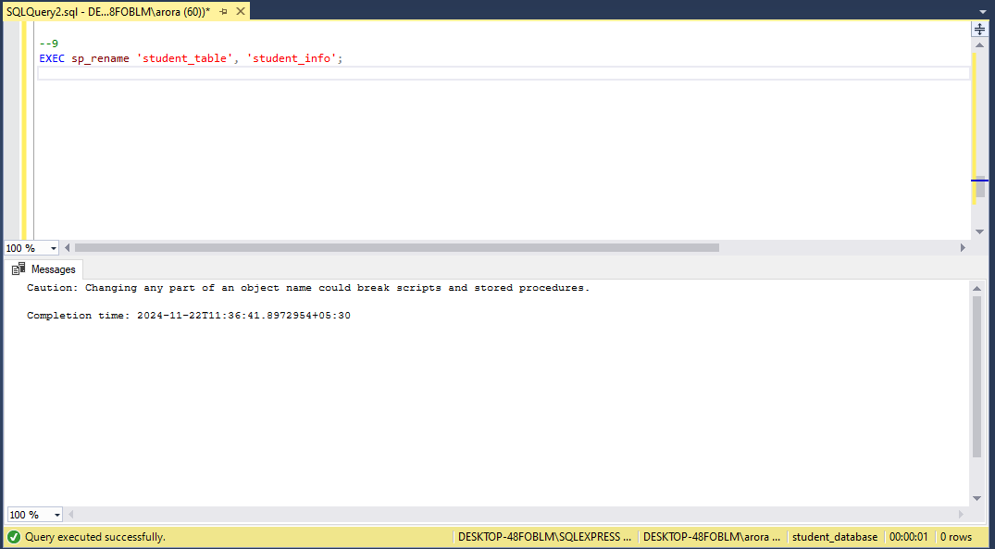

**11. Write a query to retrieve the name of the student with the highest GPA from the "student_info" table.**

**Code-** SELECT TOP 1 Stu_name

FROM student_info

ORDER BY GPA DESC;

